# Purpose

Purpose of this hands of lab is to demonstrate how to use Microsoft Cognitive Service – Custom Speech Service

# Prerequisites

1. A Microsoft account (email address)
2. GIT Bash installed in your computer - <https://git-scm.com/downloads>
3. (Optional) Enable PowerShell in Windows - <https://docs.microsoft.com/en-us/powershell/scripting/setup/installing-windows-powershell?view=powershell-6>
4. Any tool to record audio file in WAV format in your computer [ Example : “Sound Recorder App from Microsoft Store for Windows]

# Steps

1. Go to <https://www.cris.ai/> and create a free account 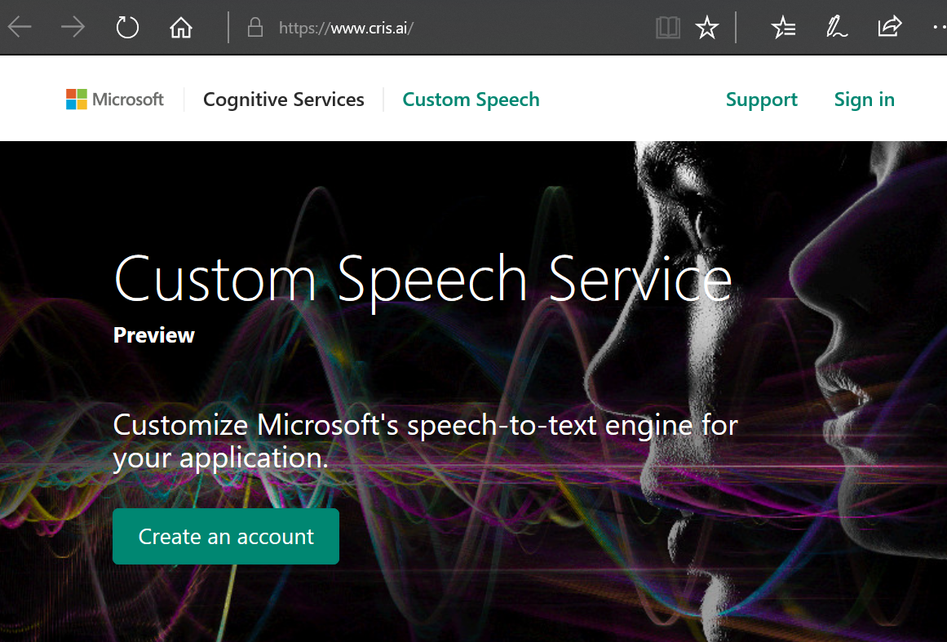
2. Accept the terms & conditions after reading the instructions and if you are okay with the same 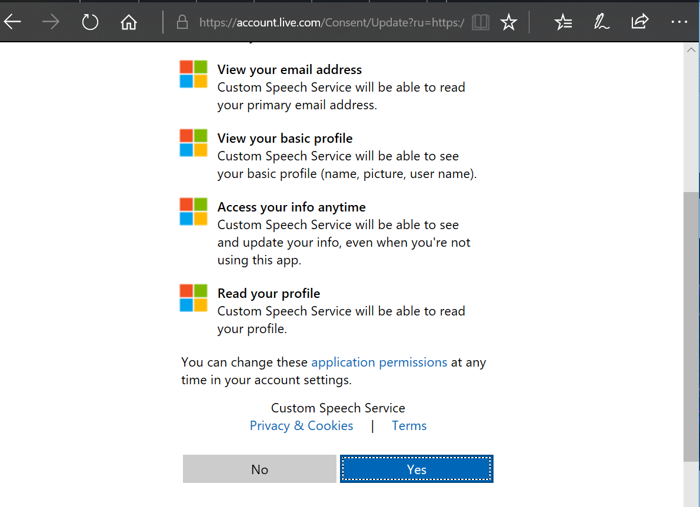
3. Complete your profile with Custom Speech (Sample given below) , and click “Start my journey”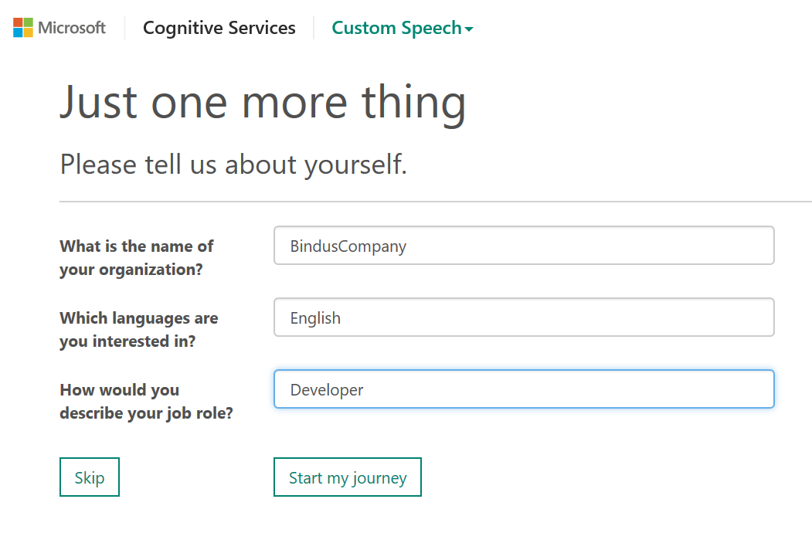
4. Clone the GIT Repository - git clone <https://github.com/Microsoft/Cognitive-Custom-Speech-Service.git> to a folder in your computer
   1. Create a folder in your computer
   2. Launch GIT Bash command line utility and go the folder you have created 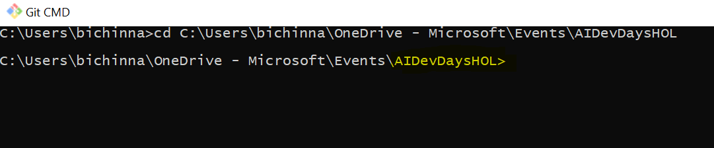
   3. Run command “git clone <https://github.com/Microsoft/Cognitive-Custom-Speech-Service.git>” to cline the files from this GIT repository to your local computer 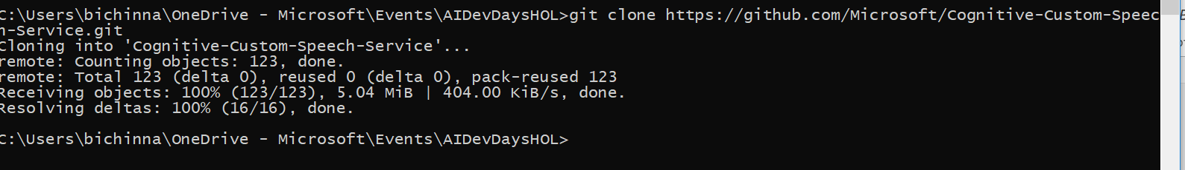
   4. Go to the folder” \Cognitive-Custom-Speech-Service\Samples\Sample1 – Biology “ within the folder you’ve copied from GIT repo and you will find a document called “Sample 1”, take time to read the document
5. Go to the folder ” \Cognitive-Custom-Speech-Service\Samples\Sample1 – Biology “ in **PowerShell Command**
6. Run this command in PowerShell “ ***Compress-Archive -Path '<FolderPath>\Test Data\Test Acoustic Data\*.wav' -DestinationPath data.zip*** “This will create a zip file containing all wav files without additional folder information as a flat list. 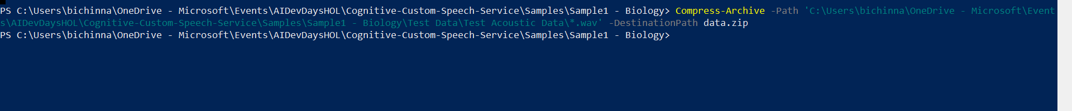
7. This should produce data.zip in <Youdfolder>\Cognitive-Custom-Speech-Service\Samples
8. Now you have everything prepared to get started with custom speech service
9. Go to “Custom Speech “ in the top navigation bar -> “Adoption Data”, The screen should looks like this if you haven’t used any Custom Speech datasets in the past, click on “Import” in “Acoustic Datasets”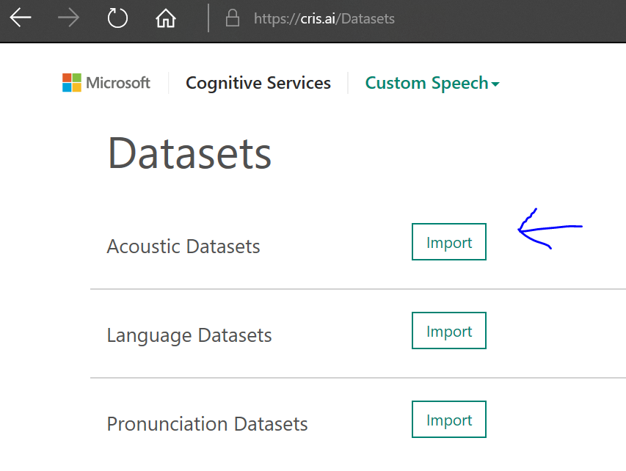
10. You will be asked to associate a subscription in order to proceed with using “Custom Speech”, you might want to click on “Get a free subscription” (if you haven existing Azure subscription, you can click on “Connect existing subscription”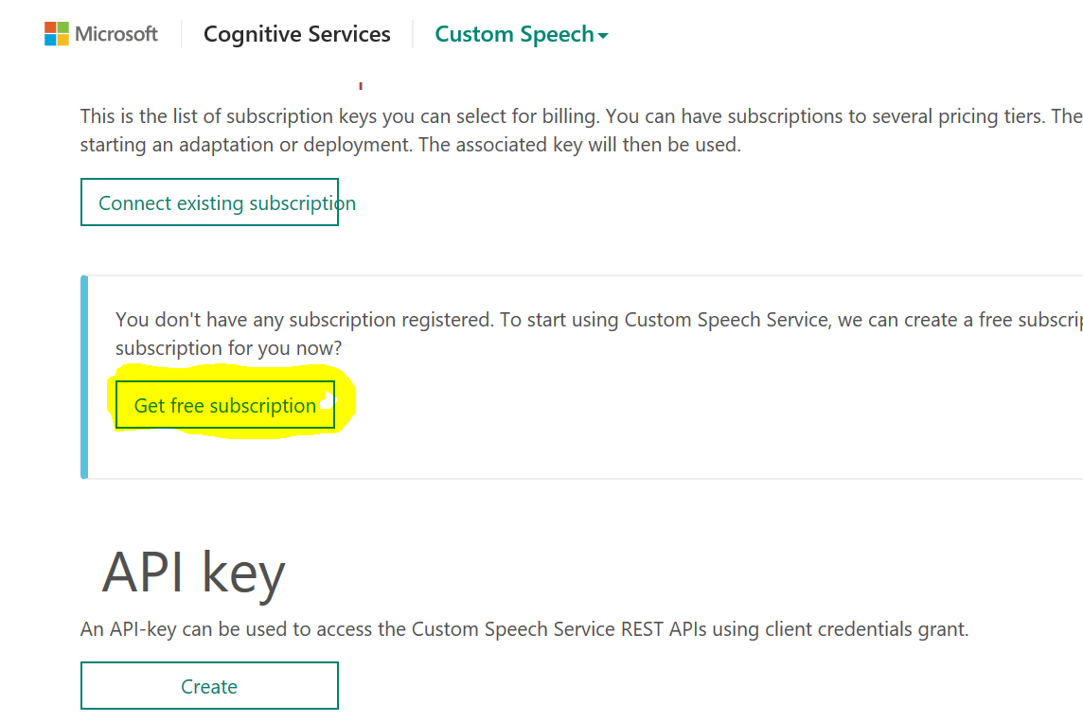
11. Once you are done with creating a free subscription or associating an existing subscription, click on “Custom Speech (on the top navigation)” -> “Adoption Data” -> “Import” on the Acoustic data. Select Transcription file and Audio file (zip file) that we generated in step #6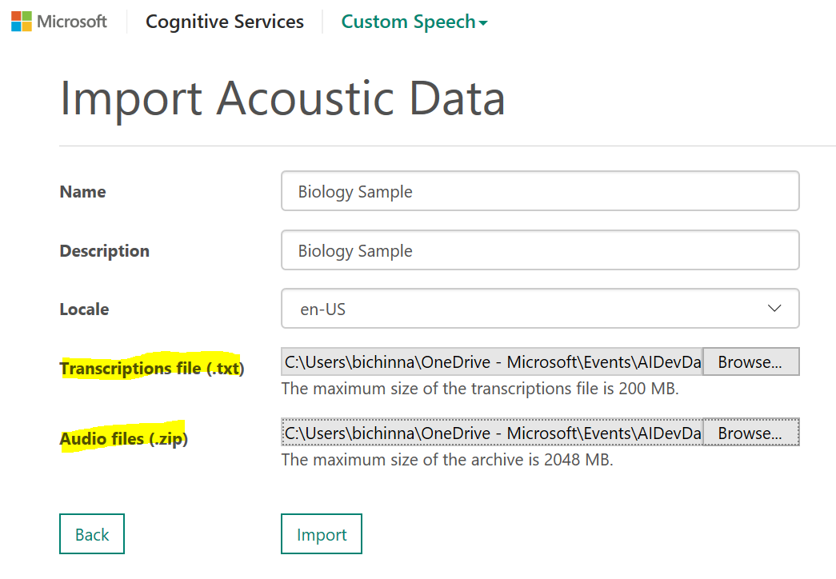
12. After Importing your datasets page should like this 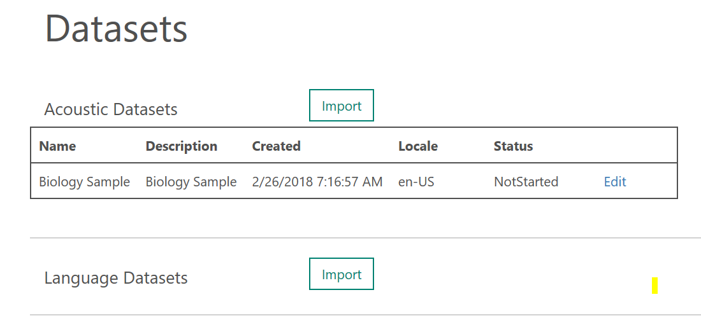
13. Navigate to “Custom Speech” -> “Acoustic Models” in the top navigation to reach “Creating Acoustic Model” page. Give a Name, Description, select acoustic data crated in the earlier step and click “**Create**”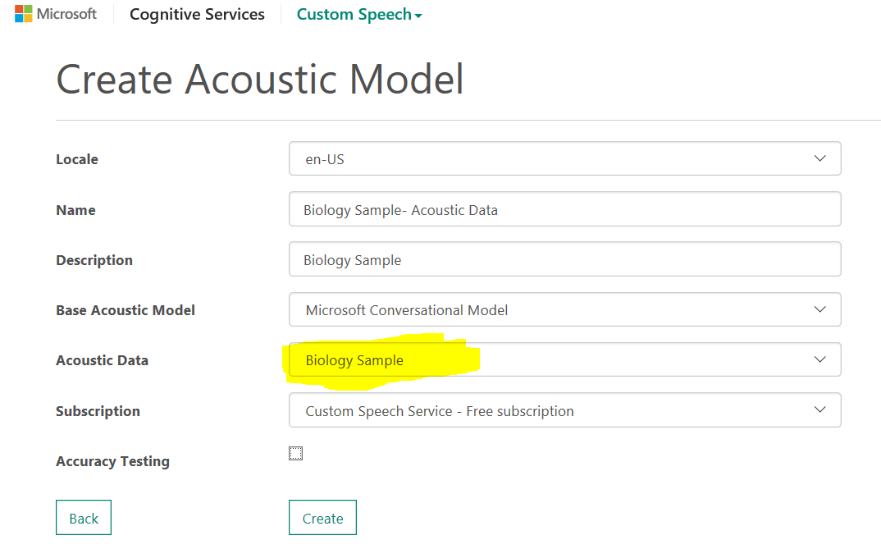
14. You should see a page like this now – Note the status “running”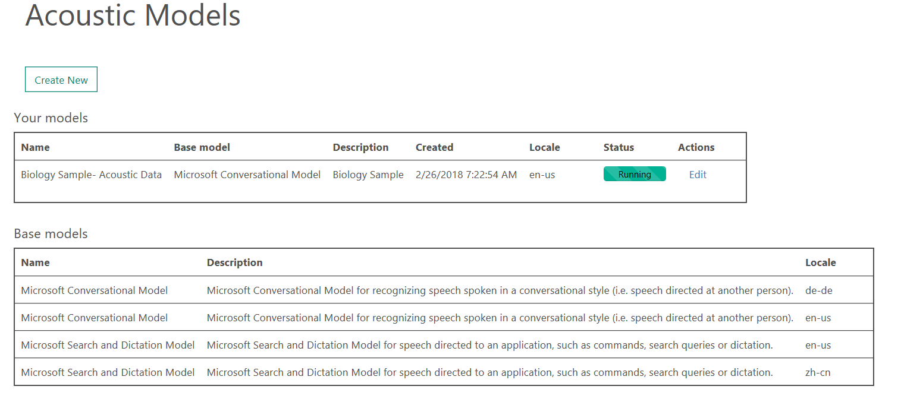
15. Navigate “Custom Speech” ->”Language Models” from the top navigation, to “Creating custom language model” page. You should see a message stating that “You have to add language data first”, Click on that link to reach the page to import language data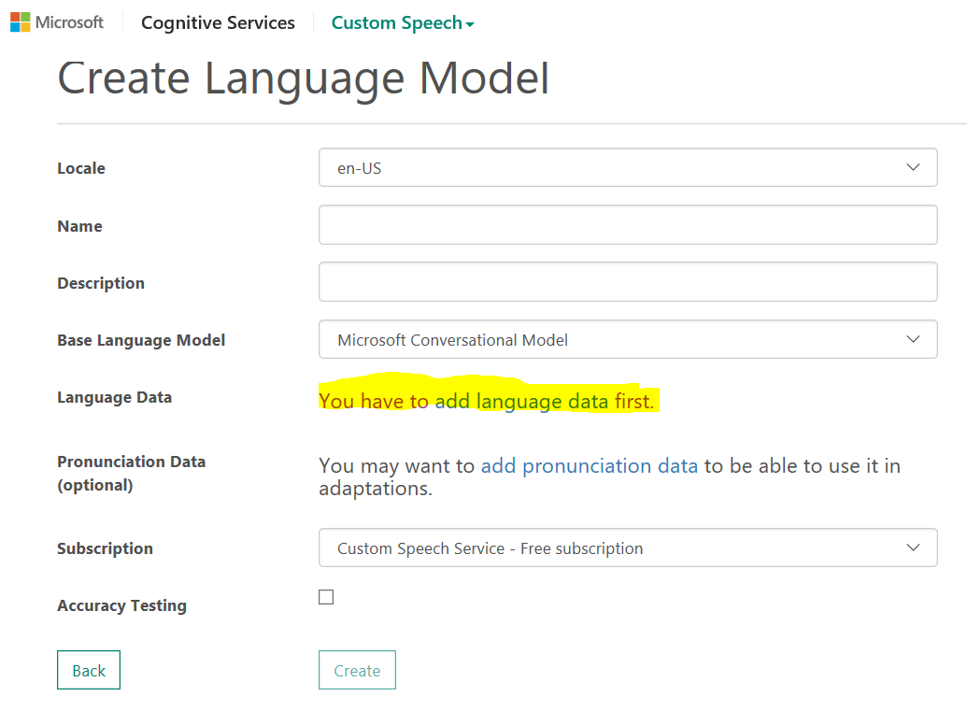
16. In the “Import Language Data” page, Give a name, Description and select the language data file from the GIT repo we cloned earlier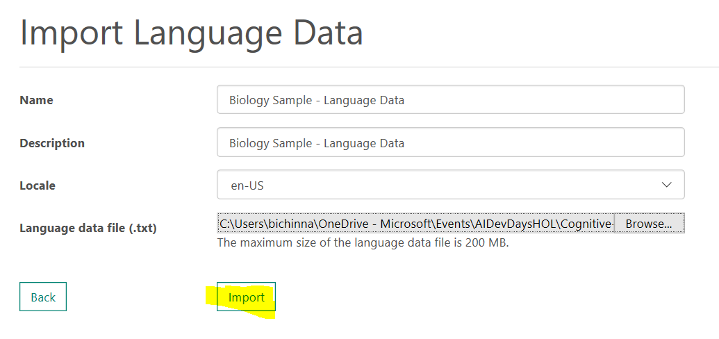
17. You will be redirected to this page with a message “Language Datasets” is Running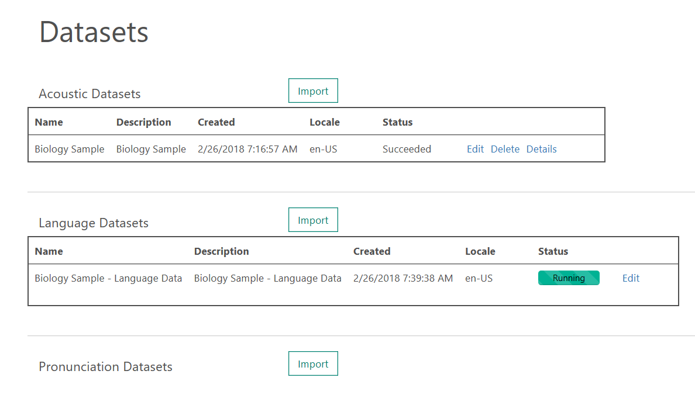
18. Now navigate to “Custom Speech” -> “Deployments” in the top navigation to reach the deployments page, click on “Create New” 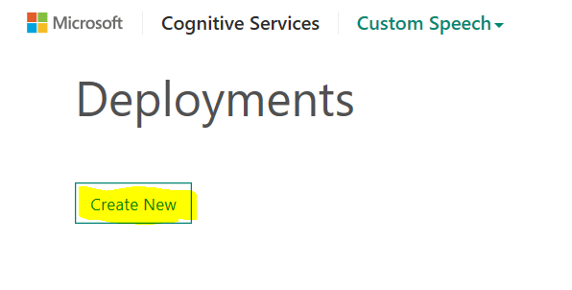
19. Provide Name and Description for the deployment, and chose “Acoustic Model” the one you have created in the earlier step, and click “Create” button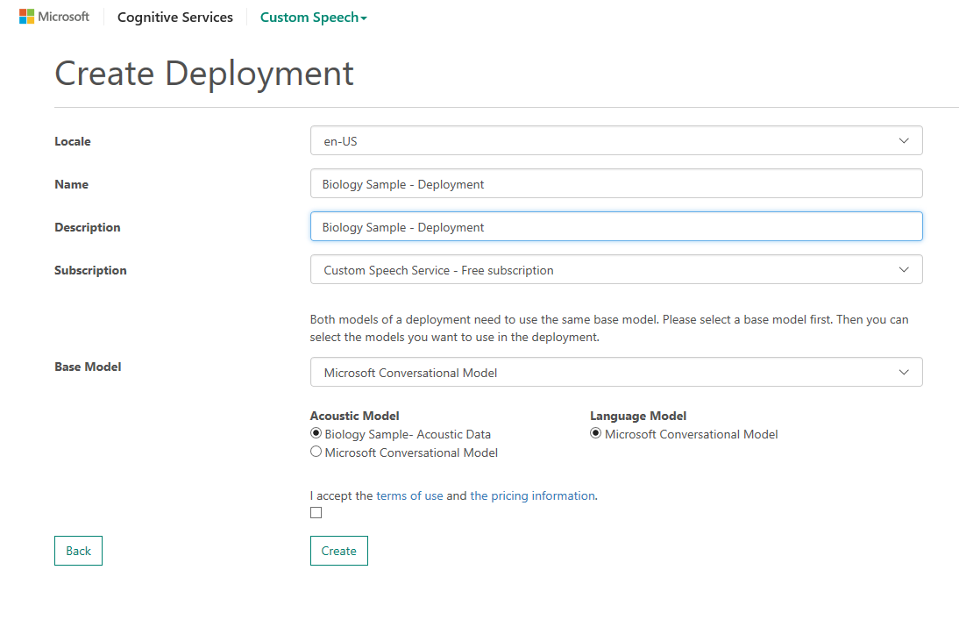
20. Now if you go to the Deployments page, you can see that the “deployment” we crated in the earlier step being listed. Click on the “Details” 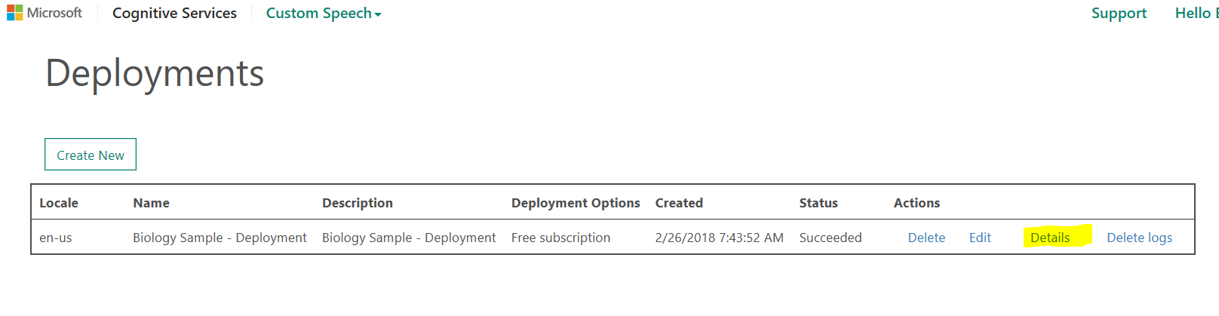
21. On the details page, you can see that there are list of end points listed out, these end points can be used from your application to interact with the custom spec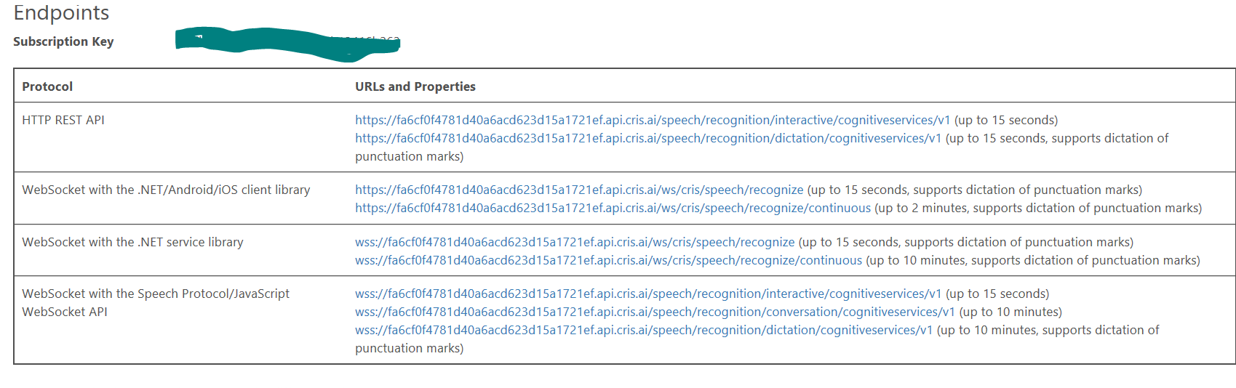
22. On the bottom of the page, you will see “Test your endpoint” area, where you can upload your own audio files and see them it gets converted to text. You might want to record an audio which contains some words from the sample we uploaded. You could use tools like “Windows Sound Recorder” App, and record your voice in WAV format and that can be used to test

